FM Tracks & Getting Paid!
Step-by-Step Guide

Minimum Data Requirements  - FM Tracks ID (Individual Transaction Screen)  - SNAP + FAB Redeemed (Vendor Reimbursements Screen)  - SNAP Transactions (Vendor Reimbursements Screen)  - # of FAB eligible producers (Post Market Report Screen)  - # of SNAP eligible producers (Post Market Report Screen)  - SNAP + FAB Distributed (Transaction Log Report) | For Direct Deposit, Every Week  We Need:  - Individual Transaction Log  - Vendor Reimbursement  - Post Market Report

*See step-by-step instructions below*
Individual Transaction
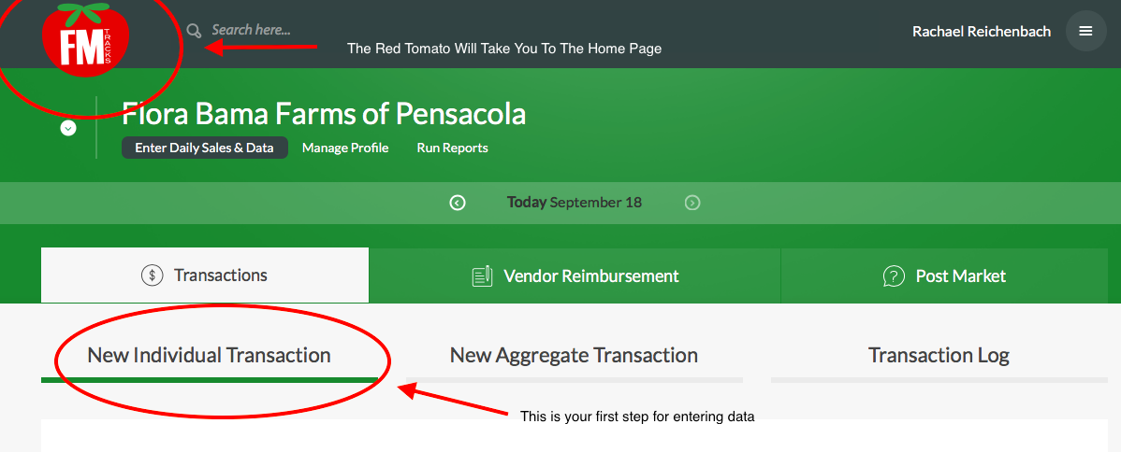
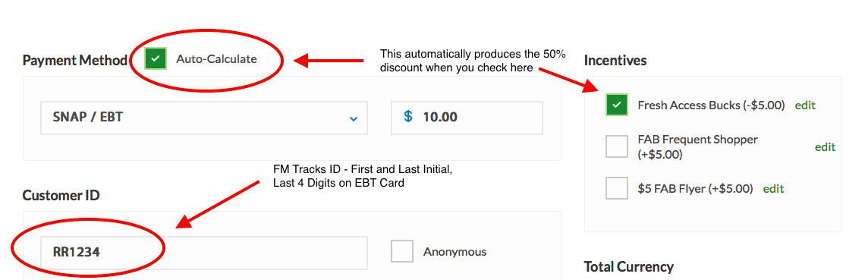
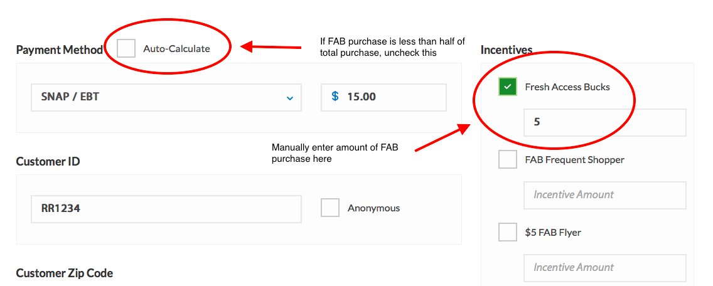
*Only input data on market days designated in your FMTracks profile.
Ex: If your outlet is open on Saturdays and Sundays, only input SNAP/FAB data on Saturdays and Sundays.*

How to Enter Vendor Reimbursement
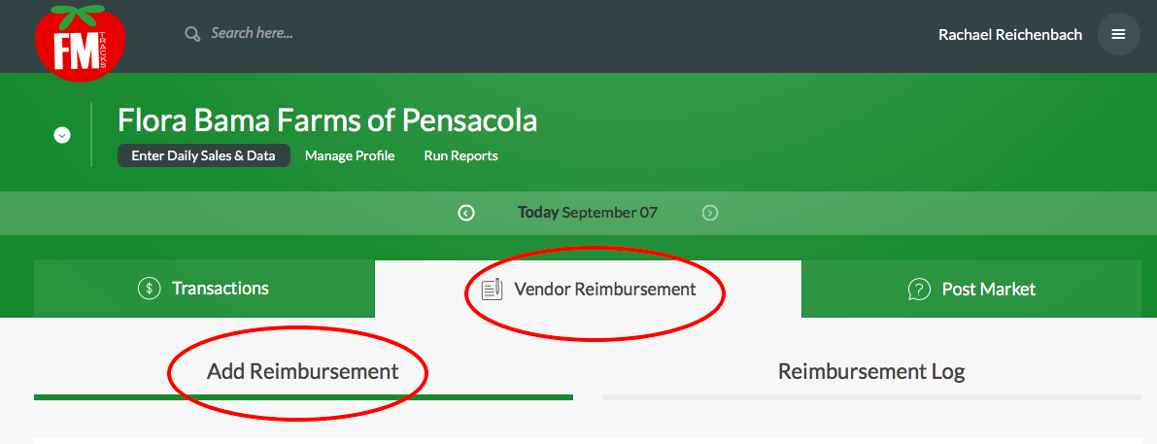
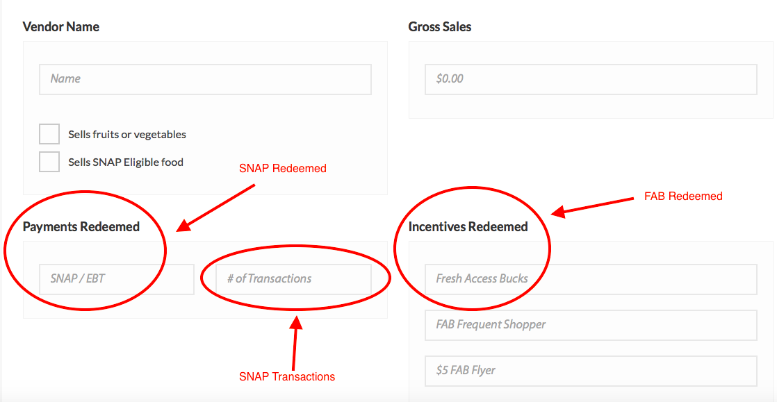
*Note if you are the only vendor at your outlet (i.e. you are a Mobile Market, Produce Stand, or CSA) enter your outlet name for ‘Vendor Name’ and check both boxes for ‘Sells fruits and vegetables’ & ‘Sells SNAP Eligible food’.*

*Gross Sales is Not Required.*

Post Market Report
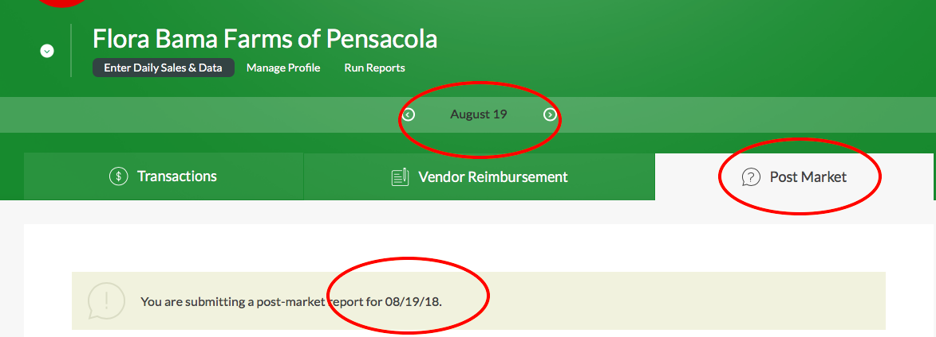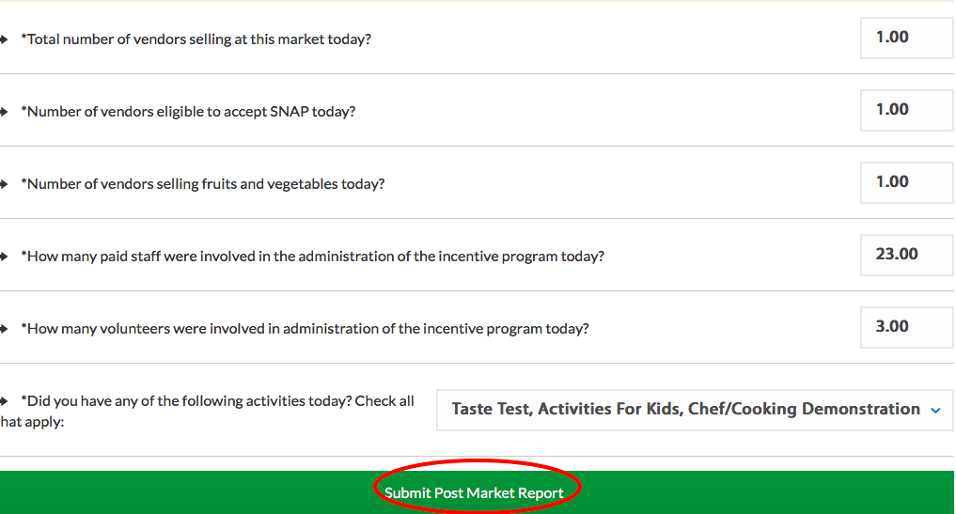
*Only input data on market days designated in your FMTracks profile.
Ex: If your outlet is open on Saturdays and Sundays, only input SNAP/FAB data on Saturdays and Sundays.*

*Note that the last question “Did you have any of the following activities today? Check all that apply.” is where you will note if you provided any nutrition education. Six distinct nutrition education events are required per year.*

How to Check Your Vendor Reimbursement
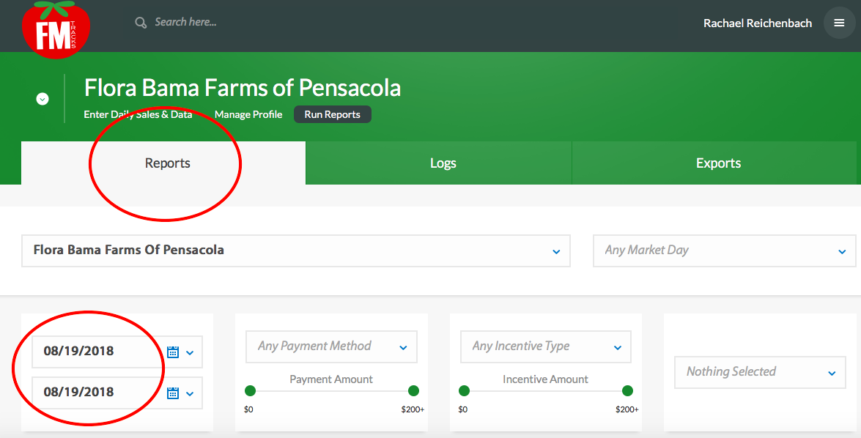

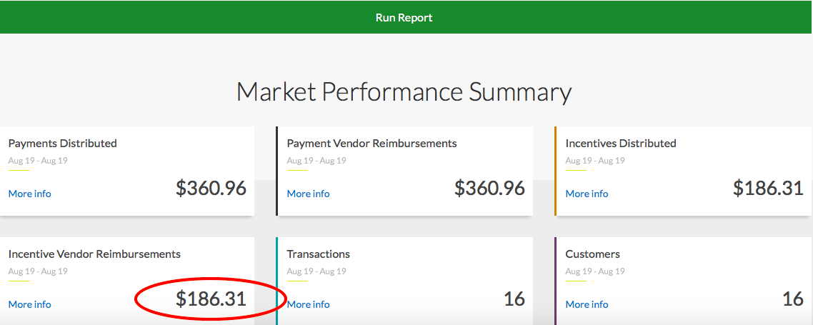

*Data entered for the latest market day(s) between Monday - Sunday will be reimbursed the following week.*

Monday | Tuesday | Wednesday | Thursday | Friday | Saturday | Sunday | Monday | Tuesday before 12 pm EST
 |  |  |  |  |  |  | FM Tracks Data for this Day is not Included in this Week’s Reimbursement | FM Tracks Data from Preceding Week (Highlighted in Pink) Will Be Reimbursed

Individual Transaction Log
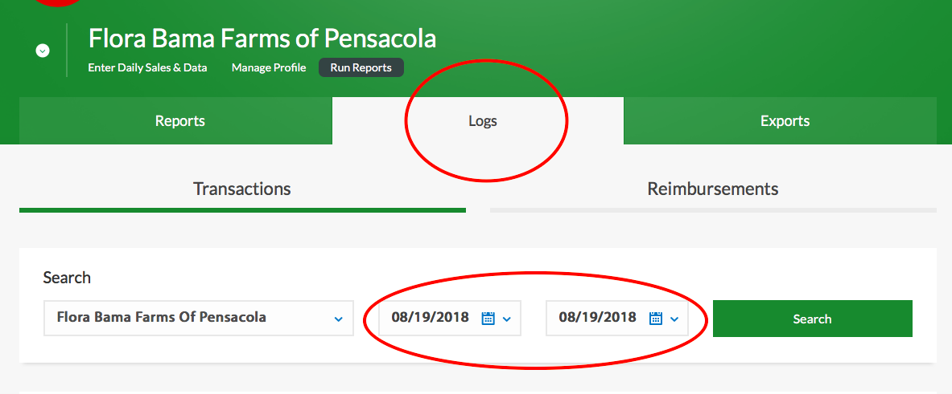
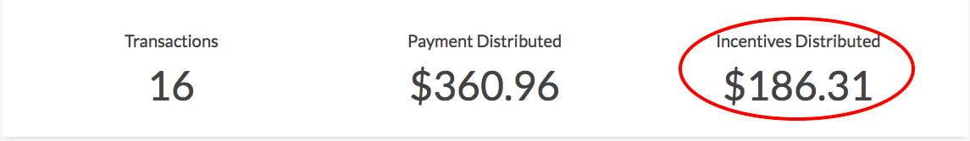
*’Incentives Distributed’ must match ‘Incentive Vendor Reimbursements’ (see the red oval at the bottom of the previous page). If they don’t match, don’t worry! Scroll down to the handy guide at the end of this document - “Updating FM Tracks Data to Square Up Distributed and Redeemed”*

Updating FM Tracks Data to Square Up Distributed and Redeemed
(When these match, your data is up to date, correct, and you’re going to get paid!)

If you need to input new transactions that you missed when you first entered your data, start here at Step One.
If you don’t have any new transactions to enter, skip down to Step Two.

Step One: When you click on 'Enter Daily Sales & Data', this window will pop up. :
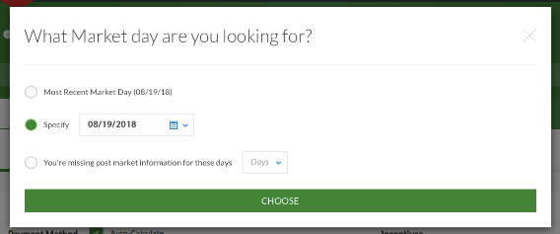
Then enter the transactions under 'New Individual Transaction' like you usually do. Make sure to choose the correct market day!

Step Two: Now you need to get the totals that you've distributed. This will help you square these numbers up with your reimbursement numbers. To do this, go to logs, and click on Transactions, and then enter in the date you're looking for (ex. August 19th), like so:

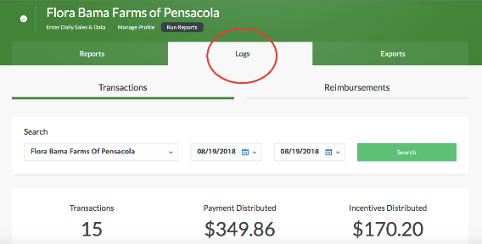
Make a note of your Payment Distributed and Incentives Distributed. Or, keep this window open, and open FM Tracks in a new window.

Then, you need to update the Reimbursements so everything matches up. You got this!

Step Three: Go to logs, click on Reimbursements, and then enter in the date you're looking for (August 19th), like so:

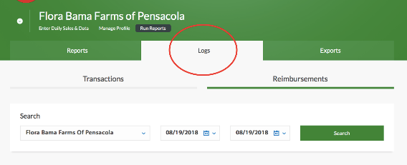
Step Four: Here's where you'll edit your reimbursements to match your transaction:

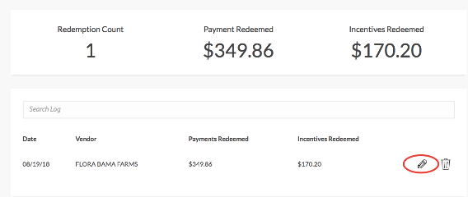

Click on that little pencil, and update the numbers so Payments Distributed matches Payments Redeemed and Incentives Distributed matches Incentives Redeemed.

