Are you a Farmers Market, CSA, Farm Stand, or Mobile Market (collectively known as an ‘Outlet’) looking to reach a new customer base at your Outlet? Are you interested in accepting SNAP (formerly known as food stamps) and other federal benefit programs at your Outlet? Does your Outlet currently accept SNAP, and are you are looking to expand participation?

Feeding Florida (FF) received a Food Insecurity Nutrition Incentive Program (FINIP) Grant from the USDA to increase sales of Florida grown fruits and vegetables to Florida consumers through July 2021. This grant increases access to and consumption of healthy, locally produced fruits and vegetables for low-income Florida residents through a nutrition incentive program called Fresh Access Bucks (FAB) at Farmers Markets, CSAs (Community Supported Agriculture Shares), Farm Stands, and Mobile Markets for Supplemental Nutrition Assistance Program (SNAP) recipients (formerly known as food stamps).

The FAB program builds a highly visible network of Florida direct-to-consumer food outlets implementing innovative programs that incentivize the use of SNAP benefits to purchase fresh fruits and vegetables directly from Florida farmers. To increase the demand for locally grown fruits and vegetables in underserved communities, FAB works with Wholesome Wave (WW), a national leader in the implementation of nutrition incentive programs.

FAB provides training and technical assistance (TA) to facilitate each Outlet’s ability to efficiently redeem federal nutrition assistance benefits, such as SNAP. Assistance includes trainings on the use of Electronic Benefits Transfer (EBT) machines (needed to redeem SNAP benefits) as necessary. As part of this TA, we assist Florida direct-to-consumer food outlets’ and farmers’ to access USDA funding that covers the cost of the EBT machine and wireless access for up to three years.

In partnership with WW, FAB also provides training and technical assistance, materials and initial incentive funding to implement Fresh Access Bucks (FAB). Through the FINIP Grant, the FAB program will expand to 60 Outlet partners statewide by July 2021. The incentive program doubles the value of SNAP benefits redeemed at Florida direct-to-consumer food outlets by providing a one-to-one match for Florida grown fruits and vegetables up to $40. For example,a SNAP cardholder who spends $10 of their benefits receives an additional $10 to purchase more fresh, local produce -- doubling revenues for Florida farmers and making healthy, fresh fruits and vegetables more affordable for low-income Florida residents.

To promote long-term sustainability, FAB works closely with local Outlets that have the capacity to provide staffing to support SNAP/EBT and incentive programs, assist in outreach, provide nutrition education supplies for SNAP recipients, collect and enter data, and administer the additional accounting required to participate in this program.

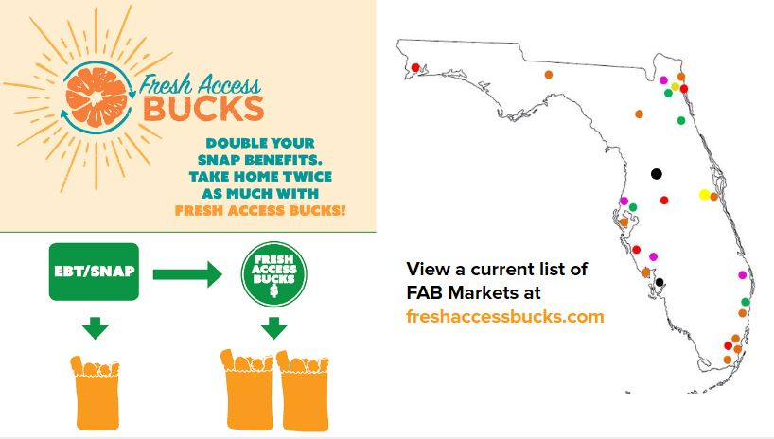
For more information, contact the FAB team at info@FreshAccessBucks.com.

Please email completed FAB application to info@freshaccessbucks.com

What type of Outlet do you represent?

_____ Farmers Market: Two or more farmer-producers that sell their own agricultural products directly to the general
public at a fixed location, which includes fruits and vegetables, meat, fish, poultry, dairy products, and grains.
_____ CSA: A method utilized by farmer-producers to sell their own agricultural products directly to the general public.
A “share” of the farmer-producer’s produce is typically made available or delivered during regular intervals during the
harvest season.
_____ Mobile Farmers Market or Mobile Produce Market: A mobile retail strategy that prioritizes the sale of local &
regional food. They are able to move to various locations easily to sell the food they have collected from producers.
_____ Farm Stand: Retail stands that sell Florida agricultural products grown or produced by the producer or other
area farmers and also sell or offer for sale non-potentially hazardous packaged food products from an approved source.
Farm stands may be located on-farm but are not required to be.

FAB Applicant Name(s):______________________________________________________________________________

Name of Outlet (one entity per application only):

_________________________________________________________________________________________________

Legal Business Name of Organization/Entity applying for FAB (i.e. LLC, corporation, 501c3, 501c4, 501c5, for-profit entity, etc.):

_________________________________________________________________________________________________

Does this Outlet have a SNAP/EBT terminal? Yes No

If not, have you started the FNS application? Yes No

Do you need assistance? Yes No
Note: If you do not have an FNS Number, or are in the process of submitting an FNS application and need assistance, contact info@freshaccessbucks.com before completing FAB application.
FNS Number: ____________________________

Phone Number: __________________________________________

Email: ___________________________________________________________________________________________

Mailing Address: ___________________________________________________________________________________

Outlet Address:________________________________________________________________________________

County: _________________________

What year was the Outlet established and opened? ____________________________________________________

Is the Outlet open year round? Yes No

If no, what is the Outlet start date: __________________________ and end date: _____________________________

What is/are the Outlet day(s) and time(s)?
_________________________________________________________________________________________________

Number of Vendors: _____________ Number of SNAP Eligible Vendors:_____________

Number of Vendors Re-Selling Produce: _____________ Number of Farmers selling Florida grown produce: _____________

Does this Outlet accept credit/debit cards? Yes No

Does this Outlet have a centralized system for SNAP/EBT transactions? Yes No

If yes, how long has this Outlet administered SNAP/EBT?_____________________________________________

If yes, who administers SNAP/EBT (a market manager, a volunteer, student/intern, vendor)? _________________

Has this Outlet accepted other state or federal benefits or implemented an incentive program before (Ex. WIC FMNP)? Yes No

If yes, please provide grant name(s), and date(s): ____________________________________________________

Does this Outlet offer nutrition education to visitors and customers? Yes No

If yes, please provide examples__________________________________________________________________

___________________________________________________________________________________________

What is the mission of this Outlet?______________________________________________________________________

_________________________________________________________________________________________________

_________________________________________________________________________________________________

Please provide examples of how this Outlet supports low income families: ______________________________________

_________________________________________________________________________________________________

_________________________________________________________________________________________________

Is the Outlet producer only? Yes No _______________________________________________________________

Please describe the community that this Outlet serves: _____________________________________________________

_________________________________________________________________________________________________

_________________________________________________________________________________________________

Have you talked with consumers & farmers about the potential of accepting SNAP/EBT and/or FAB? What is their feedback? _________________________________________________________________________________________________

_________________________________________________________________________________________________

_________________________________________________________________________________________________

Has this Outlet ever fundraised? Yes No

If yes, please provide examples__________________________________________________________________

___________________________________________________________________________________________
Fresh Access Bucks partners are required to engage in community fundraising in order to match a small portion of the funds that they are granted through the Fresh Access Bucks program. Does this Outlet have the ability to provide matching funds?

Please describe: ___________________________________________________________________________________

_________________________________________________________________________________________________

_________________________________________________________________________________________________

Does this Outlet have the ability to provide in kind support to FAB (including staffing needs, promotion, data collection, and some materials such as a tent, table, etc.)?

Please describe: ___________________________________________________________________________________

_________________________________________________________________________________________________

_________________________________________________________________________________________________

Please describe this Outlet’s community partnerships (i.e. nonprofits, county Health Department, government, community groups, local schools, libraries etc.) _____________________________________________________________________________________________

_________________________________________________________________________________________________

_________________________________________________________________________________________________

Please describe this Outlet’s outreach efforts. How does the Outlet advertise itself and its vendors in the community? _________________________________________________________________________________________________

_________________________________________________________________________________________________

_________________________________________________________________________________________________

Why is this Outlet interested in offering SNAP and FAB?
_________________________________________________________________________________________________

_________________________________________________________________________________________________

Please describe how the Outlet will successfully manage SNAP and FAB (consider staff time and capacities, community resources, and changes the Outlet may need to make to its operations to offer SNAP and FAB successfully).
_________________________________________________________________________________________________

_________________________________________________________________________________________________

What opportunities and challenges do you foresee in implementing SNAP/EBT and FAB at this Outlet or within this

community? _______________________________________________________________________________________

_________________________________________________________________________________________________

_________________________________________________________________________________________________

_________________________________________________________________________________________________

Please provide any additional comments: _________________________________________________________________

_________________________________________________________________________________________________

_________________________________________________________________________________________________

Please email completed FAB application to info@freshaccessbucks.com

Signature: __________________________________________________________ Date: __________________________

