Fresh Access Bucks
Increasing Food Access and Florida Farmer Sales at Market Outlets Statewide

Fresh Access Bucks encourages healthy behaviors by making fresh, local produce more affordable and accessible to SNAP recipients while supporting Florida’s farmers and enhancing our local economies. FAB increases the purchasing power of SNAP participants by providing a one-to-one match for Florida grown fruits and vegetables up to $40. For example, a SNAP cardholder who spends $10 of their benefits receives an additional $10 to purchase more fresh, local produce. The goals of FAB are to increase access to and affordability of fruits and vegetables in underserved communities and increase awareness of the importance of eating fresh fruits and vegetables. This program strategically partners with farmers markets, farm stands and community supported agriculture (CSAs) in and around food deserts, low-income communities, and along transportation routes.

A program of Feeding Florida, Fresh Access Bucks (FAB) began in 2013 with a Specialty Crop Block Grant under Florida Organic Growers (FOG) by the Florida Department of Agriculture and Consumer Services. In Spring of 2015 FOG was awarded the USDA’s Food Insecurity Nutrition Incentives Program (FINIP) grant in order to serve 50 markets over a 3 year period. In 2018 FAB joined Feeding Florida, the state’s largest non-profit food bank association that works directly with more than 2,500 partner agencies throughout our 14-member network. Feeding Florida seeks to build programs to provide opportunities for all individuals to have increased access to nutritious and affordable food and analyze the impact nutrition has on communities and individuals. In Fall 2018, Feeding Florida was awarded a FINIP grant to continue supporting SNAP recipients and Florida farmers throughout the state, while expanding the FAB program by adding 15 new market outlets over 3 years.

Beginning in January, 2019, Fresh Access Bucks will pilot a Florida-specific grocery store nutrition incentive program at three retail outlets, one per year, over a three year period. FAB's retail incentive program will focus on small, independent grocery, convenience of corner store outlets with a capacity and interest to purchase from Florida farmers and offer Fresh Access Bucks in a retail setting in rural, underserved communities that lack access to farmers market and food retail options.

Currently, 51 markets participate in the Fresh Access Bucks program statewide. FAB provides training and technical assistance, materials and initial incentive funding to implement the incentive program. We enter into formal contracts with markets managed by well-established organizations, that have the technical capabilities to manage the project finances and reporting. Strong and supportive market managers form the foundation for successful partnerships that commit to manage the day-to-day operation of FAB, staff and vendor training, record keeping, promotion, and leveraging of funds. Participating Outlets are expected to provide staffing for the EBT and FAB program, assist in outreach, provide supplies for the EBT and FAB booth, collect and enter data, and have the capacity to administer the additional accounting required for this program. Moreover, to promote long-term sustainability, Feeding Florida works closely with local farmers markets and organizations to expand local funding and capacity building opportunities.

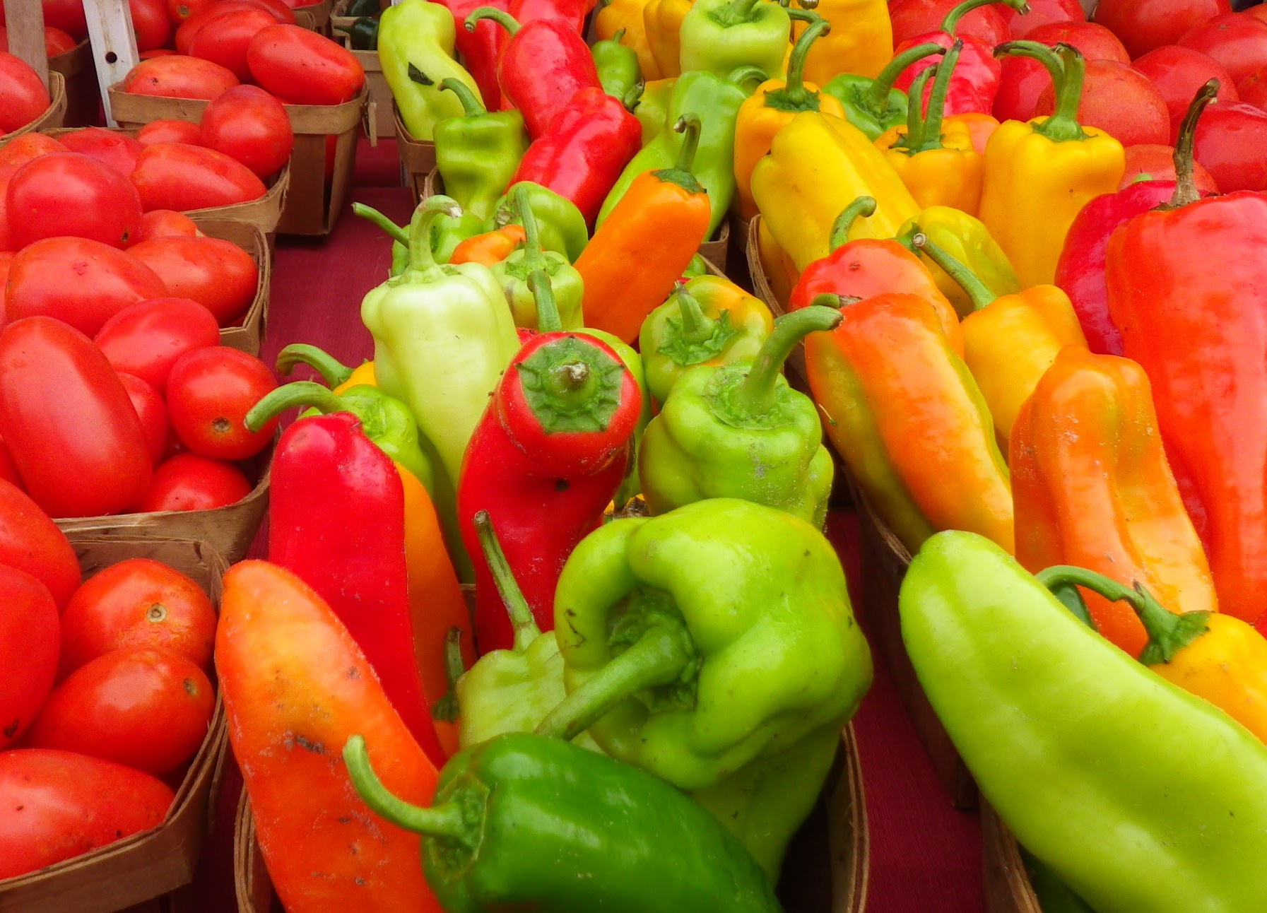
We are fortunate in Florida to have a vast network of government agencies and nonprofits partnering with us to improve access to and affordability of healthy food in our state, including but not limited to Wholesome Wave, a national leader in SNAP incentive programs, the state’s SNAP Agency - Department of Children and Families, Department of Health’s Healthiest Weight Initiative, Florida’s Chronic Disease Prevention Coalition, the Florida Department of Agriculture and Consumer Services’ Food, Nutrition and Wellness Division, and a multi-agency collaboration known as Living Healthy in Florida. In addition to our state level partners, each of our FAB markets work with their county Health Department and countless grassroots, community organizations active in underserved areas to provide input on program planning, implementation, nutrition education, outreach and evaluation.

Project Needs

Our goals are measured by the numbers of fruit and vegetable growers impacted, the total revenue generated by SNAP and incentives, the number of EBT transactions and new market shoppers. Since its inception, Fresh Access Bucks has generated over $940,000 in healthy food purchases for over 560 Florida farmers, with over 32,000 Federal Benefit Transactions (SNAP & WIC/Senior FMNP) and over 14,000 New Market Shoppers.

To be able to meet our goals, additional funding will need to be secured. Feeding Florida has received interest from across the state and is hopeful to be able to accommodate all communities that would like to benefit from this extremely effective program.

Project Opportunity

Incentive programs for fruits and vegetables are effective at promoting local economies and increase the consumption of fruits and vegetables in underserved communities. WW’s national research has found that:
- 90% of SNAP recipients reported increasing their consumption of fresh fruits and vegetables.
- On average, 27% of total market sales at participating farm-to-retail venues were from SNAP recipients.
- In response to increased sales, farmers expanded acreage/production, diversified products and added additional hoop houses or greenhouses.

Although Florida’s fruit and vegetable production is year long and the second largest in the United States, few Florida residents purchase and consume Florida-grown produce, as 85% of what is grown is exported. Despite Florida’s agricultural abundance, 3.1 million Floridians are without reliable access to a sufficient quantity of affordable, nutritious food (Feeding America, 2013). FAB has a unique opportunity to combat our state’s food insecurity while providing new market opportunities for Florida farmers. Although almost $6 billion dollars in federal nutrition assistance benefits come into Florida each year (SNAP, WIC/Senior Benefits), only .018% goes to Florida farmers (Farmers Market Coalition, 2013). People in the state’s underserved communities would substantially benefit from enhanced access to affordable, fresh Florida-grown produce at farmers markets, while providing a real immediate benefit to farmers and their communities.

Testimonials
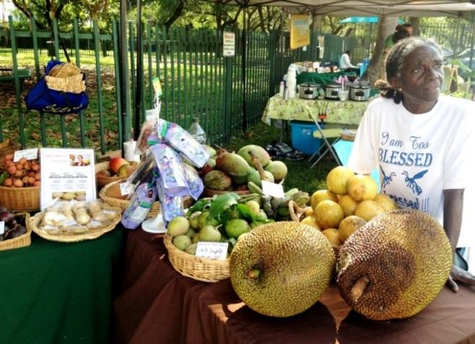
“It allows us to make healthy food accessible to people of all income levels.” – Sweetwater Organic Community Farm, Tampa
“The first year we offered the program someone cried, she was so excited that she would be able to buy organic vegetables from our market on a regular basis.” – St. Petersburg Saturday Morning Market, St. Petersburg
“It makes a big difference to me knowing my produce is going to someone who needs it.” – Siembra Farm, Gainesville Urban Oasis’ Upper East Side Market, Miami

