How to Become a Fresh Access Bucks Partner

Are you a Farmers Market, CSA, Farm Stand, or Mobile Market (collectively known as an ‘Outlet’) wanting to find new customers for the farmers and support for your Outlet? Are you interested in expanding your Outlet to accept SNAP and other federal benefit programs? Does your Outlet currently have or are you planning to install SNAP, and are looking to expand participation?

The Fresh Access Bucks (FAB) program builds a highly visible network of Florida direct-to-consumer food outlets implementing innovative programs that incentivize the use of SNAP benefits to purchase fresh fruits and vegetables directly from Florida farmers. FAB provides support and technical assistance (TA) to facilitate each Outlet’s ability to efficiently redeem SNAP benefits. This includes: assistance in completing the USDA application to become an authorized SNAP farmers market; assistance in accessing USDA funding that covers the cost of the Electronic Benefits Transfer (EBT) machine (needed to redeem SNAP benefits) and wireless access for up to three years; as well as training on the use of EBT machines.

Fresh Access Bucks provides funding to direct-to-consumer food outlets to double the value of SNAP benefits. This funding is made available through the USDA Food Insecurity Nutrition Incentive (FINI) Grant Program. For example, an individual spending $40 of their benefits receives an additional $40 to purchase Florida grown produce -- doubling revenues for Florida farmers and making healthy, fresh fruits and vegetables more affordable for low-income Florida residents.

To promote long-term sustainability, FAB works closely with local Outlets that have the capacity to provide staffing to support SNAP/EBT and incentive programs, assist in outreach, provide nutrition education supplies for SNAP recipients, collect and enter data, and administer the additional accounting required to participate in this program.

For more information, contact the FAB team at info@FreshAccessBucks.com or (352) 377-6345.

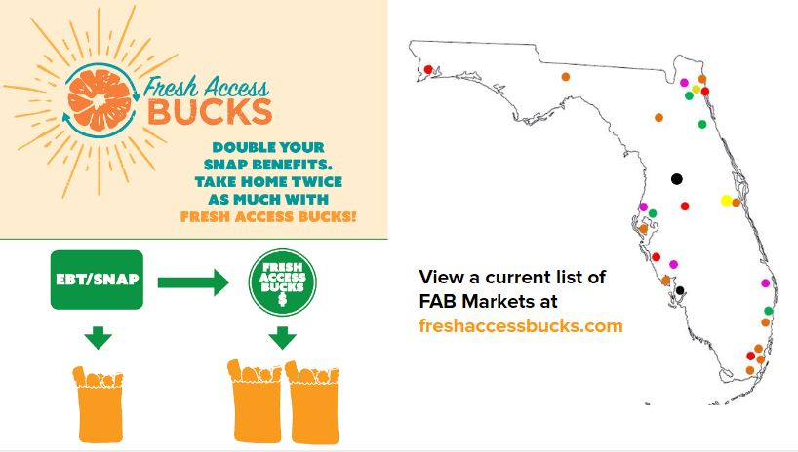
Steps to Becoming a Fresh Access Bucks Market

Step One: Complete the USDA Supplemental Nutrition Assistance Program (SNAP) application - www.fns.usda.gov/snap/retailer-apply
- Apply as a Farmer’s Market under either Direct Marketing Farmer (1 vendor with a farm-stand or on-store farm) or Farmer’s Market (2+ vendors in a set location)
- You will provide basic information about your market including: hours, location, and estimated sales data
- Your market will need to choose a Responsible Official whom the USDA will hold responsible for SNAP transactions. This person will need to submit Social Security Card, Photo ID, and sign the Certification Statement.
- You can complete the online application in as little as 15 minutes!
- Once the USDA reviews and approves your application you will be given an FNS number.

Step Two: Complete the USDA Food and Nutrition Services FREE EQUIPMENT application– https://www.mysnapebtequipment.com/
- This application requires an FNS number. Apply only once approved by the USDA
- If you are approved for the free equipment, you have a choice of providers who will provide a free three year merchant services contract as well as a free machine to accept EBT.

Step Three: Complete the Fresh Access Bucks (FAB) application –
www.freshaccessbucks.com
- Following SNAP authorization and after some time doing SNAP transactions and building a customer base, consider applying for FAB.

